

Project Management System
Software Requirement Specification

Project Code: PMS
Document Code: PMS_SR– v1.0

Fpt University HCMC
May 27th 2012

1 Record of change
*A - Added M - Modified D - Deleted
Effective Date | Changed Items | A*  M, D | Change Description | New Version
27/05/2012 | Initial | A | Add project over view | 1.0
27/05/2012 | Introduction | A | Add introduction | 1.0
27/05/2012 | Overall Description | A | Add Overall Description | 1.0
27/05/2012 | Functional Requirement | A | Add Functional Requirement | 1.0
27/05/2012 | Non-functional Require | A | Add Non-functional requirement | 1.0
27/05/2012 | Supporting Information | A | Add supporting information | 1.0
27/05/2012 | Overall Description | A | Add overall description | 1.0
27/05/2012 | Use case model | A | Add usecase model | 1.0

2 SIGNATURE PAGE

ORIGINATOR: Manh Hoang Truong May 27th, 2012
Developer

REVIEWERS: Ngo Duc Duy May 27th, 2012
Developer

APPROVAL: Le Ngoc Thach May 27th, 2012
Project Manager

3 TABLE OF CONTENTS
1 Record of change 2
2 SIGNATURE PAGE 3
3 TABLE OF CONTENTS 4
4 Introduction 6
4.1 Purpose 6
4.2 Scope 6
4.3 Definitions, Acronyms, and Abbreviations 6
4.4 References 7
4.5 Overview 7
5 Overall Description 8
5.1 Product perspective: 9
5.2 Product functions: 9
5.3 User characteristics: 10
5.4 Constraints: 10
5.5 Assumptions and dependencies: 10
5.6 Requirements subsets: 10
6 FUNCTIONAL Requirements 11
6.1 Home Screen 11
6.2 Log-in 12
6.3 Log-out 13
6.4 Monitor current level 14
6.5 Turn on/off pump 15
6.6 Raise alarm 17
6.7 View Log 19
7 Use case model 20
7.1 Actors 20
7.2 Use cases 21
7.3 Main Use Case Diagrams of the PMS 22
7.4 Log-in 23
7.5 Log-out 24
7.6 Monitor current level 25
7.7 Turn on/off pump 26
7.8 Raise Alarm 27
7.9 View Log 28
8. NON-FUNCTIONAL Requirements 30
8.1 Usability 30
8.2 Reliability 30
8.3 Performance 31
8.4 Supportability 31
8.5 Design Constraints 31
8.6 On-line User Documentation and Help System Requirements 32
8.7 Purchased Components 32
8.8 Interfaces 32
8.9 Licensing Requirements 32
8.10 Legal, Copyright, and Other Notices 32
8.11 Applicable Standards 33
9. Supporting Information 34

4 Introduction
In this accelerating of technologies and economics, Project Management is growing extremely importance to organizations because it deals effectively with the management of change. Modern economics and business environment are complicated than ever, organizations are beginning to realize that the traditional forms of management cannot adapt efficiently to the dynamics and its resulting chaos.

In the future, software industries could very well depend on how quickly the procedures and systems of project management are adopted. Therefore, Project Manager will play a very important role within organizations. Our mission is to provide an online system which actively assists those managers in managing their project. The approaches and techniques that are used in the project management process are of interest to all those who wish to be more certain about achieving predetermined targets.

4.1 Purpose
This Software Requirements Specification provides a complete description of all the functional requirements, non-functional requirements, constraints and other requirement specification of the “Project Management System”.

4.2 Scope
This project aims to create an online software project management system. With friendly interface, powerful tools, OOPMS provides powerful and efficient customized service for numerous kinds of managers from small to medium projects. Besides, OOPMS can be deployed on J2EE portal servers (JSR168, JSR268).

4.3Definitions, Acronyms, and Abbreviations

Table 1 Abbreviations
No. | Key word | Meaning
1 | PM | Project Manager
2 | PMS | Project Management System
3 | ISO | International Standard Organization

Table 01: Abbreviations

4.4 References
FSOFT PMS System

4.5 Overview
The rest of this document includes four chapters:
The 2nd“Overall Description” chapter describes an overview description of this document. It lists all the functions, constraints of the application.
The 3rd“Functional Requirements” chapter lists all the required functions for PMS.
The 4th“Non-functional Requirements” chapter provides non-functional requirements, constraints of the system that shall be satisfied.
The final “Supporting Information” chapter gives supporting and additional information in order to make the PMS easier to use.

5 Overall Description

This chapter describes an overview description of this document by listingall the functions, characteristics, constraints of the application.

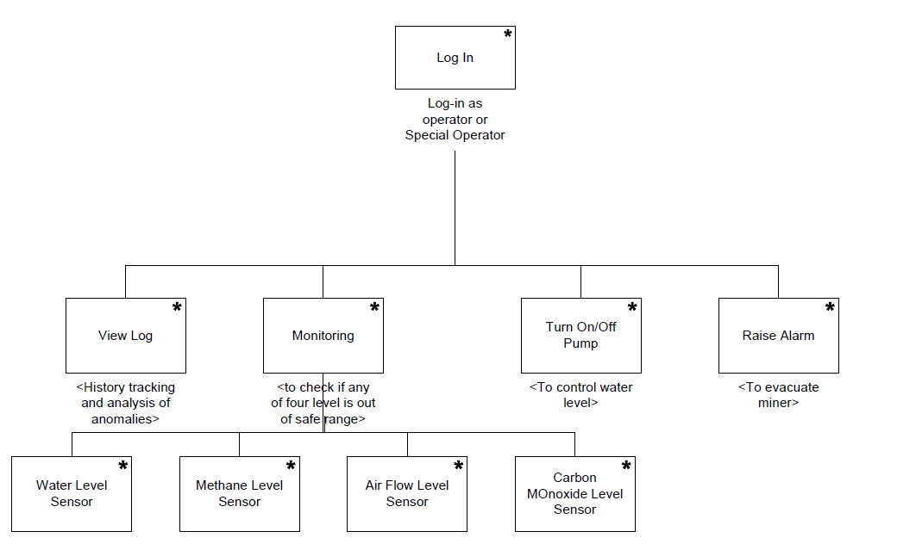
Figure 1PMSOverview

5.1 Product perspective:
The PMS shall be developed to manage requirements, tasks, defects, time tracking and report in software projects.

5.2 Product functions:
The PMS provides functions as below :

1. Dashboard: show present status of projects which have been created in OOPMS. Project managers and others senior manager can easily track and monitor status of their project.

2. Planner:

a. Allow users import Microsoft Project file (*.mpp) into OOPMS and in the future, users also can edit and export *.mpp files at OOPMS;

b. Create task and assign task to team members.

3. Report: support creating report of project weekly and allow Team leader of project add more comments to the report.

4. Project Eye: manage detail information about a specific project.

5. Time Tracking: manage working time of team members.

6. DMS: manage defects of projects.

7. Requirement: include list of requirements (function, non-function). Allow users to keep track status of those requirements

8. Admin: Allow admin to manage users and manage system data

.5.3 User characteristics:
The PMSis designed for human operatorswho are assumed to have the following characteristics:
+ Fully understand the process of Safety Control System and how it is important inside a mine.
+ No special knowledge or skills.
+ No training in computer system use.

5.4 Constraints:
The PMS is a real time system that is responsible for managing project information. It must operate correctly, accurately and in time.

5.5 Assumptions and dependencies:
None

5.6 Requirements subsets:
None

6 FUNCTIONAL Requirements
Dashboard
Planner
Report

Admin
Project Eye
(Product + stages + Deliverables)

Timesheet
DMS

Requirement

Include: Description, Use Case, Use Case scenario

This chapter of the document describes all the functions that the PMSapplication shall provide, and how the system operating these functions using natural language and model, chart.

6.1 Home Screen

6.1.1 Screen Layout
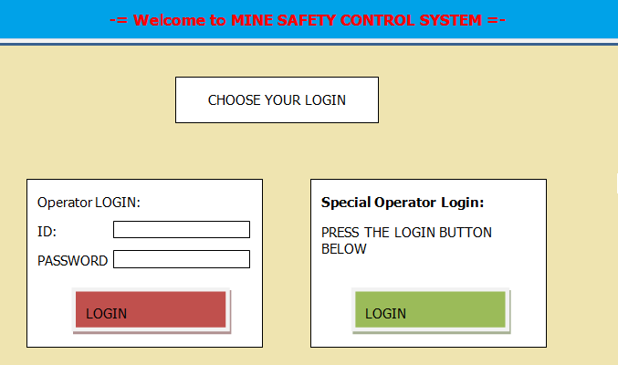
Figure 3 Home Screen

6.2 Log-in

6.2.1 Screen Layout
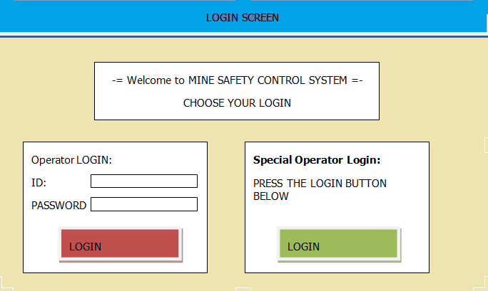
Figure 4 Login Screen

6.2.2 Description
This function shall beused to check username and password to log into the system. Only logged in user can use the system.
The PMSallows Special Operator adding new user, deleting current user, and editing current user’s information.
PMSshall clearly define Operator or Special Operator with different authorization from Log-in phase.
Users’ attributes shall include:
Table 2 Users' attributes
No. | Field name | Remarks
1 | User ID | Each user has a unique identification number
2 | Name | User’s name
3 | Address | User’s publications receiving address
4 | Phone | User’s contact phone number
5 | Position | Position in Organization
6 | Department | Department that user belong to
7 | Working status | Working status : on work or on vacation
Table 02: Users’ attributes

6.3 Log-out

6.3.1 Screen Layout
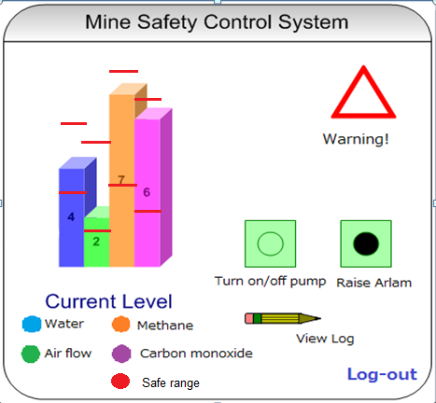
Figure 5 Logout Screen

6.3.2 Description
This function provide user to log out the system. Only logged in user can log out the system.

6.4 Monitor current level

6.4.1 Screen Layout
Figure 6 Monitor Screen

6.4.2 Description
This function provide user to monitor Water, Methane, Air Flow, Carbon monoxide Level inside a mine, give warning when the level reach nearby the critical range and allow user to turn on/off pump as well as raise alarm when needed, view log.
Item (Water, Airflow, Methane, Carbon monoxide) Level attributes shall include:
Table 3 Items' attributes
No. | Field name | Remarks
1 | Item ID | Each Item has a unique identification number
2 | Name | Item’s name
3 | Description | Item’s description
4 | High Level | Min acceptable level
5 | Low Level | Max acceptable level
6 | Critical range | Critical range
Table 03: Items’ attributes

6.5 Turn on/off pump

6.5.1 Screen Layout
Figure 7 Turn on/off pump

6.5.2 Description
This function provide user to turn on/off pump to control water level.
Pump actuator can be control automatically by PMS controller or manually by operators.
Manually By Operators - Use Case 03a:
Name : Turn on/off pump
Goal : Control water level
Actors : All users (include operator and special operator), pump actuator, water sensors
Pre-conditions: Logged user
Post-conditions: None
Main Flow:
Currently in monitor screen
Raise warning to user whenever water level enter critical range
Receive turn on/off pump demand from user
Turn on/off pump as order
Display monitor screen for user keep checking
Automatically by PMS- Use Case 03b:
Name : Turn on/off pump
Goal : Control water level
Actors : pump actuator, water sensors
Pre-conditions: None
Post-conditions: None
Main Flow:
Currently in monitor screen
Raise warning to user whenever water level enter critical range
Automatically Turn on/off pump by pump actuator whenever water level reach high or low point.
Display monitor screen for user keep checking

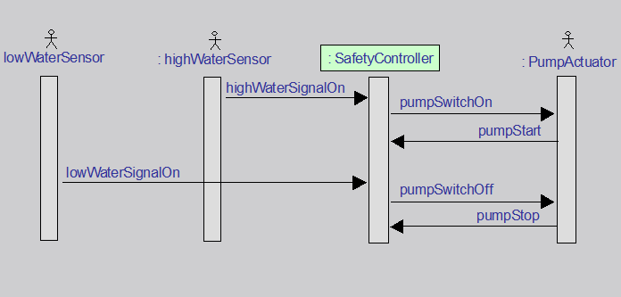
Figure 8 Water sensor operation - Sequence Diagram

6.6 Raise alarm

6.6.1 Screen Layout
Figure 9 Raise Alarm

6.6.2 Description
This function provide user to raise alarmwhen one of the item’s level out of safe rangeto evacuate miners.
Alarm actuator can be control automatically by PMScontroller or manually by operators.
Manually by Operators - Use Case 04a:
Name : Raise Alarm
Goal : Evacuate miners
Actors : All users (include operator and special operator), alarm actuator, methane sensors, or airflow sensors, or carbon monoxide sensors.
Pre-conditions: Logged user
Post-conditions: None
Main Flow:
Currently in monitor screen
Raise warning to user when item level enter critical range
Receive raise alarm demand from user
Activate alarm system as order
Save log data into hard drive and display monitor screen for user keep checking
Automatically by PMS- Use Case 04b:
Name : Raise Alarm
Goal : Evacuate miners
Actors : Alarm actuator,methane sensors, or airflow sensors, or carbon monoxide sensors.
Pre-conditions: None
Post-conditions: None
Main Flow:
Currently in monitor screen.
Raise warning to user when item level enter critical range.
Raise Alarm by alarm actuator whenever one of those level reach high or low point.
Save log data into hard drive and display monitor screen for user keep checking.

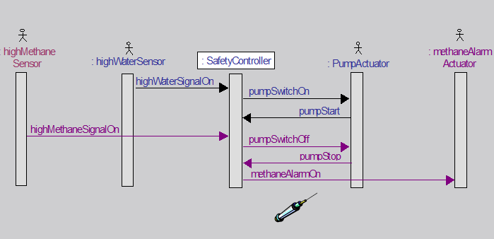
Figure 10 Methane Sensor operation - Sequence Diagram

6.7 View Log

6.7.1 Screen Layout
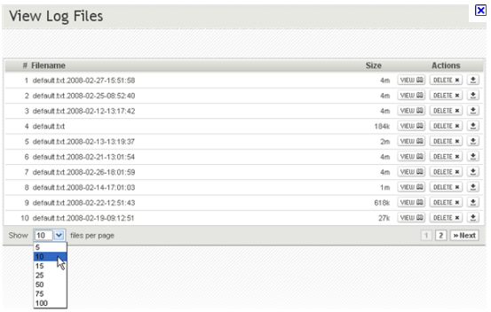
Figure 11 View Log Screen

6.7.2 Description
This function provide user to view log of the PMS.
Use Case 05:
Name : View Log
Goal : Provide log data
Actors : All users (include operator and special operator)
Pre-conditions: Logged user
Post-conditions: None
Main Flow:
Currently in monitor screen
Receive View Log command
Go to View Log screen and display Log data

7 Usecase model
This chapter describes PMS’s features and functions using abstract Use Cases and detail scenarios.
A use case is a description of a sequence of actions (including itsvariations) that the system carries out to create an observable result foran actor.
A scenario is atemporal sequence of interaction events among agent instances.

7.1 Actors
Table of all main functions’ actors:
This table indicates which actors associating with which functions.

Table 4 Main functions' actors
 | Main functions | Operator | Special Operator | Water Sensors | Methane, Airflow, Carbon monoxide sensors | Pump actuator | Alarm actuator
1 | Log-in | x | x
2 | Log-out | x | x
3 | Monitor current level |  |  | x | x
4 | Turn on/off pump | x | x | x |  | x
5 | Raise Alarm | x | x |  | x |  | x
6 | View Log | x | x

Table 04: Main functions’ actors

7.2 Use cases
This table list all use cases for each corresponding system functions.

Table 5Use cases List
System Functions | Main Use Cases | Use Case ID
Log-in
 | Log-in Use Case | UC_1.1
Log-out
 | Log-out Use Case | UC_1.2
Monitor current level
 | Monitor current level Use Case | UC_1.3
Turn on/off pump
 | Manually turn on/off pump Use Case | UC_1.4a
 | Automatically turn on/off pump Use Case | UC_1.4b
Raise Alarm
 | Manually raise alarm Use Case | UC_1.5a
 | Automatically raise alarm Use Case | UC_1.5b
View Log
 | View Log Use Case | UC_1.6

Table 05: Use cases List

7.3 Main Use Case Diagrams of the PMS
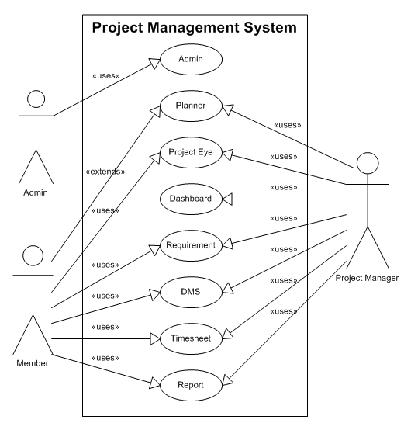
Figure 12 Main Use Case Diagrams of the PMS
This main Use Case Diagrams of the PMS show all main functions placinginside the system boundary and all actors that associate with those functions.

7.4Log-in
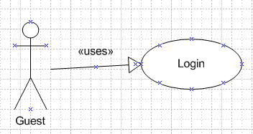
Figure 13Log-in Use Case model

Use Case scenario:
Table 6Log-in scenario
User Case ID | UC_1.1
Name | Log-in Use Case
Goal | Authenticate guests then authorize them.
Actors | Guest
Pre-conditions | None
Post-conditions | None
Main Flow | 1. User goes into PMS Homepage.  3. Users enter user’s information: Username, Password and hit “Log-in” button. | 2. Display Home Screen and request user to log in.  4. Validate user’s information.  5.Display monitor screen to corresponding user.
Exception | If username or password is not correct, the PMSwill show error message and ask user to log in again.
Open Issues | N/A

Table 06: Log-in scenario

7.5 Log-out
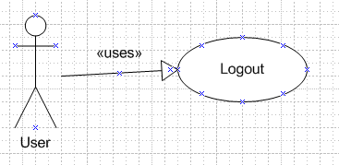
Figure 14:Log-out Use Case model

Use Case scenario:
Table 7Log-out scenario
User Case ID | UC_1.2
Name | Log-out Use Case
Goal | Provide Log-out function for User to check out
Actors | User(include member, admin, project manager)
Pre-conditions | Logged user
Post-conditions | None
Main Flow | 1. Users are using PMS and click “Log-Out” button. | 2. Log user out and display Home Screen.
Exception | None
Open Issues | N/A

Table 07: Log-out scenario

7.4 Search Timesheet
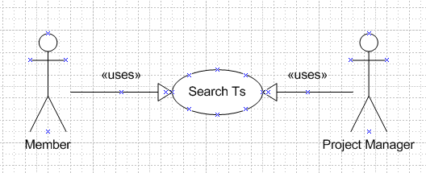
Figure 13 Search timesheet Use Case model

Use Case scenario:
Table 6 Log-in scenario
User Case ID | UC_1.1
Name | Search Timesheet Use Case
Goal | This function allows users can search timesheet.
Actors | Add Timesheet
Pre-conditions | User logins must be member of project
Post-conditions | None
Main Flow | 1. Users logins to Timesheet system.  3. Click button Search | 2. Select search condition.
Open Issues | N/A

Table 06: Search timesheet scenario

7.5 Add timesheet
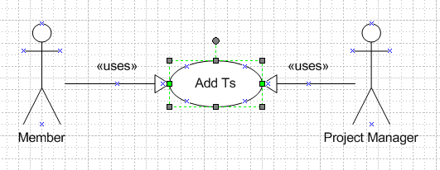
Figure 14: Add time sheet Use Case model

Use Case scenario:
Table 7 Log-out scenario
User Case ID | UC_1.2
Name | Add Timesheet t Use Case
Goal | This function allows users can add a new timesheet record
Actors | Add Timesheet
Pre-conditions | User logins must be member of project
Post-conditions | None
Main Flow | 1. Users logins to Timesheet system. | 2. Click button add new.
Exception | None
Open Issues | N/A

Table 07: Add timesheet scenario

7.6 Update timesheet
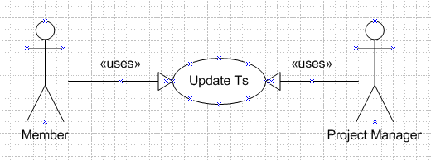
Figure 15 Update timesheet Use Case model

Use Case scenario:
Table 8 Update timesheet scenario
User Case ID | UC_1.3
Name | Update timesheet Use Case
Goal | This function allows users can update timesheet records.
Actors | Member , Project Manager
Pre-conditions | User logins must be member of project
Post-conditions | None
Main Flow | 1. User logins to Timesheet system.  3. Click button update | 2. Select timesheet record to update
Exception | None
Open Issues | N/A
Table 08: Update timesheet scenario

7.7 Delete timesheet
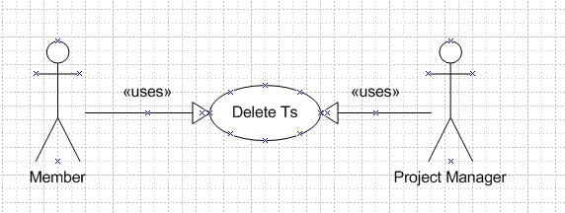
Figure 16 Delete timesheet Use Case model

Use Case scenario:
Table 9 Turn on/off pump scenario
User Case ID | UC_1.4
Name | Delete timesheet Use Case
Goal | This function allows users can delete timesheet records.
Actors | Member , Project Manager
Pre-conditions | User logins must be member of project
Post-conditions | None
Main Flow | 1. User logins to Timesheet system.  3. Click button delete | 2. Select timesheet record to delete
Exception | None
Open Issues | N/A

Table 09: Delete timesheet scenario

7.8 Approve/ Reject timesheet
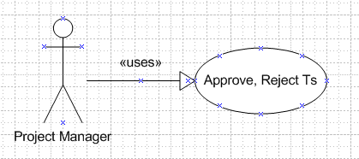
Figure 17 Approve/ Reject timesheet Use Case model

Use Case scenario:
Table 10 Approve/ Reject timesheet scenario
User Case ID | UC_1.5-a/b
Name | Approve/ Reject timesheet Use Case
Goal | Allow project manager to approves or reject members‘ timesheet records
Actors | Project manager
Pre-conditions | Logged users as role project manager
Post-conditions | None
Main Flow | 1. User logins to Timesheet system  as role project manager  3. Click button approve or reject | 2. Select Timesheet to approve or reject
Exception | 3a go with 4a as well as 3b followed by 4b.
Open Issues | N/A
Table 10: Raise alarm scenario

7.9 Search defect
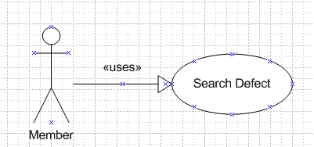
Figure 18 Search defect Use Case model

Use Case scenario:
Table 11 Search defect Scenario
User Case ID | UC_1.6
Name | Search defect Use Case
Goal | This function allows users can search defect.  Defect has 3 kinds : open defect, closed defect, leakage
Actors | Member
Pre-conditions | Logged user
Post-conditions | None
Main Flow | - Users login into DMS system  - Click button search | - Select search condition
Exception | None
Open Issues | N/A
Table 11: Search defect scenario

7.10 Add defect
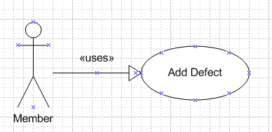
Figure 18 Search defect Use Case model

Use Case scenario:
Table 11 Search defect Scenario
User Case ID | UC_1.6
Name | Add defect Use Case
Goal | This function allows users can add defect.  When defect was added, member become creator, defect change status to opened
Actors | Member
Pre-conditions | Logged user
Post-conditions | None
Main Flow | 1Users login into DMS system | - Click button add new
Exception | None
Open Issues | N/A
Table 11: Search defect scenario

7.11 Update defect
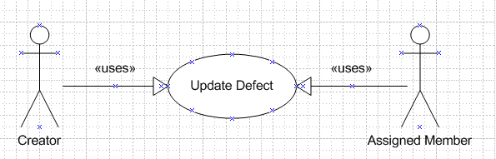
Figure 18 Search defect Use Case model

Use Case scenario:
Table 11 Search defect Scenario
User Case ID | UC_1.6
Name | Update defect Use Case
Goal | This function allows users can update defect.  Creator can change status of defect from opened to cancelled or corrected.  Assigned member can change status of defect to opened, canceled or closed.
Actors | Member
Pre-conditions | Logged user
Post-conditions | None
Main Flow | 1Users login into DMS system  3..Click button update | - Select defect
Exception | None
Open Issues | N/A
Table 11: Search defect scenario

7.6 Monitor current level

Figure 15Monitor current level Use Case model

Use Case scenario:
Table 8Monitor current level scenario
User Case ID | UC_1.3
Name | Monitor current Level Use Case
Goal | Monitor items’ level by keep receiving data from sensors and display statistics in monitor screen.
Actors | Water sensors, Methane, Airflow, Carbon monoxide sensors
Pre-conditions | System active
Post-conditions | None
Main Flow | 1. Sensors keep sending data. | 2. Receiving data and display statistics by graph in monitor screen.
Exception | None
Open Issues | N/A
Table 08: Monitor current level scenario

7.7 Turn on/off pump
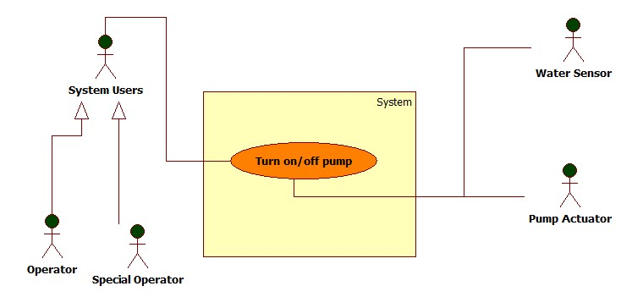
Figure 16Turn on/off pump Use Case model

Use Case scenario:
Table 9Turn on/off pump scenario
User Case ID | UC_1.4-a/b
Name | Manually /Automatically Turn on/off pump Use Case
Goal | Turn on/off pump to control water level
Actors | Operator (include special operators), water sensors, pump actuators
Pre-conditions | Logged users, water level data measured by sensor is reaching High or Low point
Post-conditions | None
Main Flow | 1. Water sensors send data  3a. Operator hits “Turn on/off pump” button.  3b. No respond from operator  5. Pump actuators receive and perform the task. | 2. Receive data, display statistics graph. Water level reach High or Low point. Issue a warning.  4a. Receive command and send command to Pump actuators  4b. Automatically send command to Pump actuators
Exception | 3a go with 4a as well as 3b followed by 4b.
Open Issues | N/A
Table 09: Turn on/off pump scenario

7.8 Raise Alarm
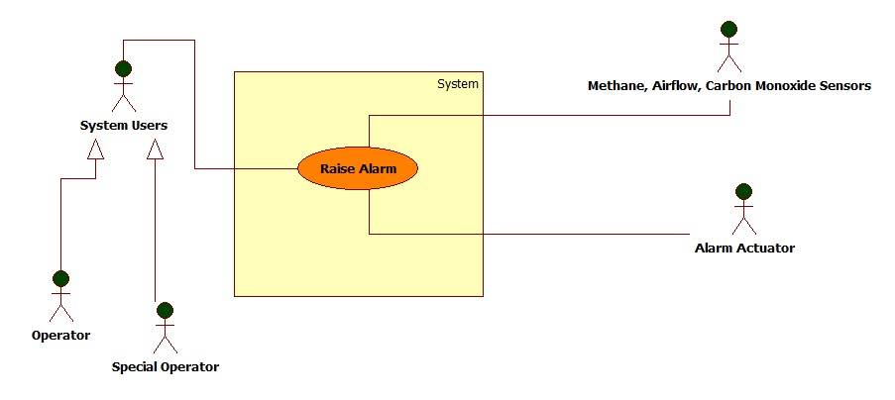
Figure 17Raise alarm Use Case model

Use Case scenario:
Table 10Raise alarm scenario
User Case ID | UC_1.5-a/b
Name | Manually /Automatically Raise Alarm Use Case
Goal | Raise Alarm when items’ level reach High or Low point to evacuate miners.
Actors | Operator (include special operators), Alarm Actuator, Methane – Airflow – Carbon monoxide sensors
Pre-conditions | Logged users, Methane or Airflow or Carbon monoxide level data measured by sensors is reaching High or Low point
Post-conditions | None
Main Flow | 1. Sensors send data  3a. Operator hits “Turn on/off pump” button.  3b. No respond from operator  5. Alarm Actuators receive and perform the task. | 2. Receive data, display statistics graph. Methane or Airflow or Carbon monoxide level reaches High or Low point. Issue a warning.  4a. Receive command and send command to Alarm Actuators  4b. Automatically send command to Alarm Actuators
Exception | 3a go with 4a as well as 3b followed by 4b.
Open Issues | N/A
Table 10: Raise alarm scenario

7.9 View Log
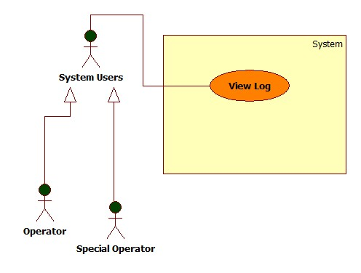
Figure 18View log Use Case model

Use Case scenario:
Table 11 View log Scenario
User Case ID | UC_1.6
Name | View Log Use Case
Goal | Provide View Log function for sensor readings and pump operation records for history tracking and analysis of anomalies.
Actors | Operator (include special operators)
Pre-conditions | Logged user
Post-conditions | None
Main Flow | - Users are using PMSand click “View Log” button. | 2. Display Log View Screen.
Exception | None
Open Issues | N/A
Table 11: View log scenario

8. NON-FUNCTIONAL Requirements
This chapter of the document describes all the non-functions requirement of the PMS.
The PMS’s usability, availability, performance are very important factors to ensure that the system operate effectively and keep hundred miners safe.

8.1 Usability
The PMS usability is the key factor to ensure that the system run exactly as well as the operators can control the system efficiently.
The PMS application shall provide clear, friendly and easy interface to operate so that system users have to spend no more than one hour learning to use the system.

8.1.1 Background knowledge
PMS users are assumed to have very basic knowledge at using computer systems.

8.1.2 Training
Operators’ training time requirement: 60 minutes.

8.2 Reliability

8.2.1 Availability
Whenever the system is during operation time no matter how many people working inside, the PMS has to be ON.

8.2.2 Mean Time between Failures (MTBF)
Mean Time between Failures (MTBF): more than 6 months.

8.2.3 Mean Time to Repair (MTTR)
Mean Time To Repair (MTTR): less than 48 hours.

8.2.4 Accuracy
Accuracy: 100%

8.2.5 Maximum Bugs and Defect Rate
Maximum Bugs and Defect Rate: 0.3 bugs per thousand lines of code (0.3 bugs/KLOC).

8.2.6 Critical Bugs
Critical bugs:
+ Loss ofLog: No
+ Unable to operate any function: No

8.3 Performance

8.3.1 Response Time
Response time for a respond:
Average: 50 milliseconds
Maximum: 80 milliseconds

8.3.2 Capacity
Only one operator at the same time.

8.3.3 Resource utilization
Memory:
+ 512MB of RAM
Operating System:
+ Microsoft Windows XP or newer version
+ Mac OS X 10.0 or newer version
+ Linux 3.5 or newer version

8.4 Supportability

8.4.1 Coding standards
According to “Standard Java Coding Convention”
– 09be-HD/PM/HDCV/FSOFT - Version 1/1.

8.4.2 Maintenance Utilities
Support working hours phone call technical support: 8:00 to 16:00 from Monday to Friday.

8.5 Design Constraints
Coding standard:
+ This application will be developed in Java programming language, version J2EE 6.
Software process requirements:
+ The software process shall confront to the CMMI 5 standard.
Developmental tools:
+ This application will be developed using Eclipse from Sun Microsystems.

8.5.1 Software Languages
GUI , Help documents, all other support documents are in English.

8.5.2 Software Process Requirement
The software process has to meet the CMMI 5 standard.

8.5.3 Development Tools
The PMS shall be developed using Eclipse 3.6 , SQA activity using FSOFT template and j-unit.

8.6 On-line User Documentation and Help System Requirements
The deployment of the application shall be provided by a technical agent include full help document for user.

8.7 Purchased Components
None

8.8 Interfaces

8.8.1 User Interfaces
As shown in Functional requirements – chapter 6
8.8.2Hardware Interfaces
API to interact with sensors are provided in advance.

8.9 Licensing Requirements
The PMS is only applicable for Project Management Department, which legally buy this product. No other use is legal.

8.10 Legal, Copyright, and Other Notices
This PMS is protected under the national law of copyright.

8.11 Applicable Standards
The system shall confront to the ISO 90003:2001 standard.

9. Supporting Information

List of figures:
Figure 1 PMSOverview 8
Figure 2 Derived use case diagram 9
Figure 3 Home Screen 11
Figure 4 Login Screen 12
Figure 5 Logout Screen 13
Figure 6 Monitor Screen 14
Figure 7 Turn on/off pump 15
Figure 8 Water sensor operation - Sequence Diagram 17
Figure 9 Raise Alarm 17
Figure 10 Methane Sensor operation - Sequence Diagram 18
Figure 11 View Log Screen 19
Figure 12 Main Use Case Diagrams of the PMS 22
Figure 13 Log-in Use Case model 23
Figure 14: Log-out Use Case model 24
Figure 15 Monitor current level Use Case model 25
Figure 16 Turn on/off pump Use Case model 26
Figure 17 Raise alarm Use Case model 27
Figure 18 View log Use Case model 28

List of tables:
Table 1 Abbreviations 6
Table 2 Users' attributes 12
Table 3 Items' attributes 14
Table 4 Main functions' actors 20
Table 5 Use cases List 21
Table 6 Log-in scenario 23
Table 7 Log-out scenario 24
Table 8 Monitor current level scenario 25
Table 9 Turn on/off pump scenario 26
Table 10 Raise alarm scenario 27
Table 11 View log Scenario 28

